TRAINING SESSION TOPIC :
TRAINING SESSION AIM :
4 CORNER | TECHNIQUE | TACTIC | PHYSICAL |  | PSYCHOSOCIAL FACTORS
EMPHASIS
DATE : |  | AGE GROUP : |  | COACH :
WARM UP |  | FIGURES |  | COACHING POINTS
MAIN TOPIC |  | FIGURES |  | COACHING POINTS
COOL DOWN |  | FIGURES |  | COACHING POINTS
TRAINING SESSION TOPIC :
TRAINING SESSION AIM :
4 CORNER | TECHNIQUE | TACTIC | PHYSICAL |  | PSYCHOSOCIAL FACTORS
EMPHASIS
DATE : |  | AGE GROUP : |  | COACH :
WARM UP |  | FIGURES |  | COACHING POINTS
 |  | 
 |  | 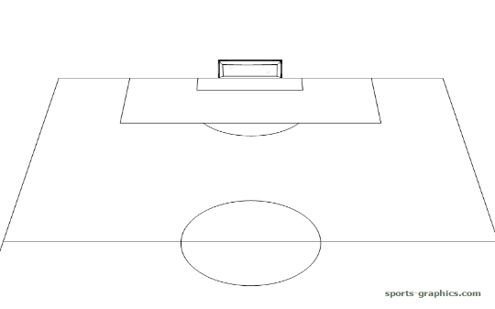
MAIN TOPIC |  | FIGURES |  | COACHING POINTS
 |  | 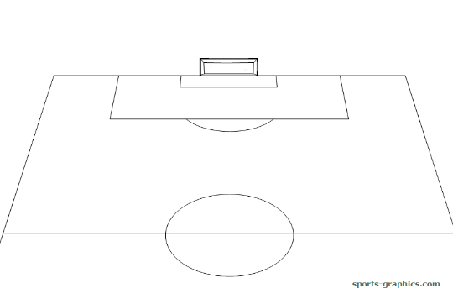
 |  | 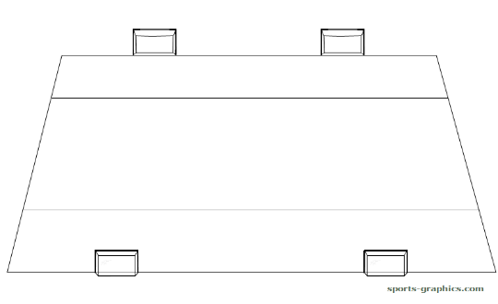
 |  | 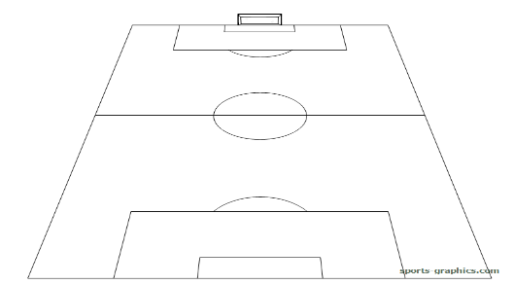
COOL DOWN |  | FIGURES |  | COACHING POINTS

TRAINING SESSION TOPIC :
TRAINING SESSION AIM :
4 CORNER | TECHNIQUE | TACTIC | PHYSICAL |  | PSYCHOSOCIAL FACTORS
EMPHASIS
DATE: |  | AGE GROUP : |  | COACH :
WARM UP |  | FIGURES |  | COACHING POINTS
 |  | 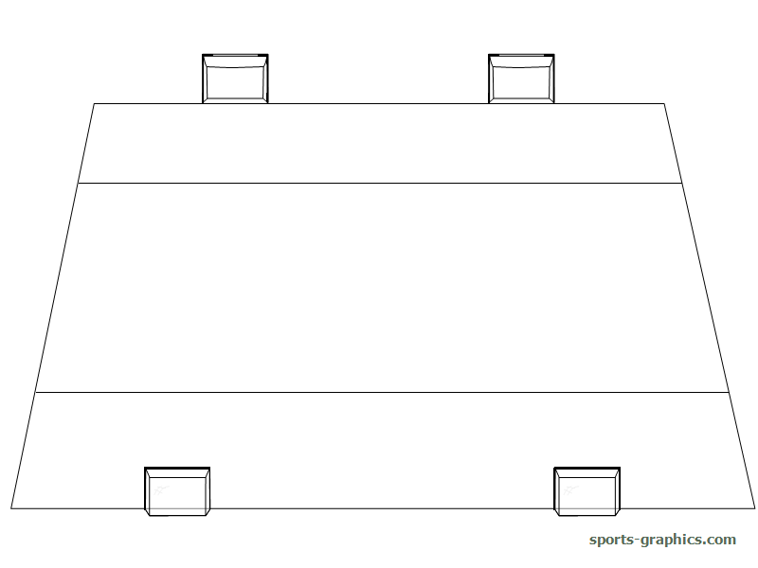
 |  | 
MAIN TOPIC |  | FIGURES |  | COACHING POINTS
 |  | 
 |  | 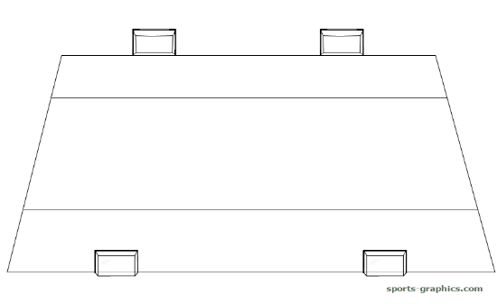
COOL DOWN |  | FIGURES |  | COACHING POINTS
TRAINING SESSION TOPIC :
TRAINING SESSION AIM :
4 CORNER | TECHNIQUE | TACTIC | PHYSICAL |  | PSYCHOSOCIAL FACTORS
EMPHASIS
DATE : |  | AGE GROUP : |  | COACH :
WARM UP |  | FIGURES |  | COACHING POINTS
 |  | 
 |  | 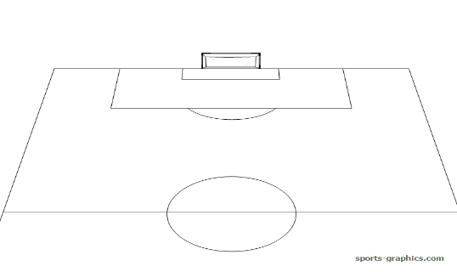
MAIN TOPIC |  | FIGURES |  | COACHING POINTS
 |  | 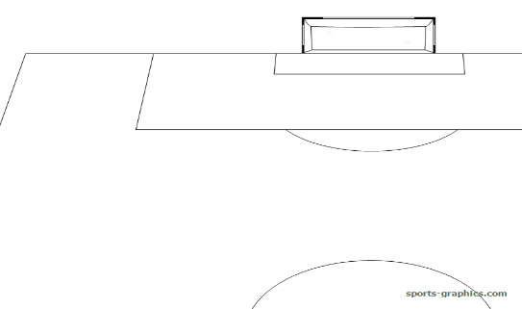
 |  | 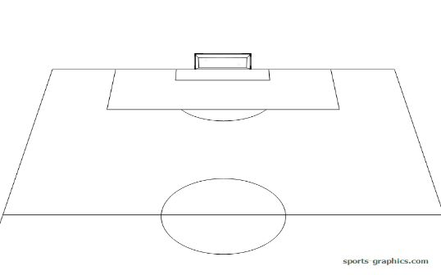
 |  | 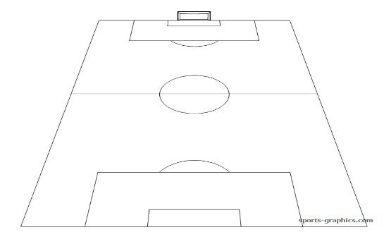
COOL DOWN |  | FIGURES |  | COACHING POINTS

TRAINING SESSION TOPIC :
TRAINING SESSION AIM :
4 CORNER | TECHNIQUE | TACTIC | PHYSICAL |  | PSYCHOSOCIAL FACTORS
EMPHASIS
DATE : |  | AGE GROUP : |  | COACH :
WARM UP |  | FIGURES |  | COACHING POINTS
MAIN TOPIC |  | FIGURES |  | COACHING POINTS
 |  | 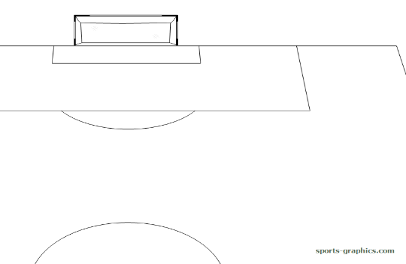
COOL DOWN |  | FIGURES |  | COACHING POINTS

